**SUPPLEMENTARY MATERIAL – Annotated screenshots of the BED Calculator**

**Further development of spinal cord re-treatment dose estimation: including radiotherapy with protons and light ions.**

Joshua W. Moore, Thomas E. Woolley, John W. Hopewell and Bleddyn Jones.

Biomedical Physics & Engineering Express xx, xxx – xxx, 20xx

This document contains example screenshots of the GUI. Figure 1 is an example of the GUI layout for a proton retreatment while figure 2 is an example of the GUI for a photon retreatment. It must be emphasized that there are distinctions between the two, in particular, for the differences in inputs and outputs. The annotated figures are placed here to aid the user and should be used in conjunction with the main text.

**Figure 1. Annotated screenshot of the GUI with initial proton treatment and proton retreatment window selected and default values. A-D are the tab buttons to select the corresponding combination of proton-photon treatments. E-F are checkboxes that fix the RBE at 1.1 for the initial proton treatment and proton retreatment respectively. G refers to the ${LET}_{u}$ input boxes for both initial treatment and retreatment. H refers to the ${LET}_{x}$ input boxes for both initial treatment and retreatment. I refers to the ${LET}_{r}$ input boxes for both initial treatment and retreatment. J is the input box for retreatment proton dose. K is the input box time-elapsed between initial treatment and retreatment. L is input box for the conservative factor. M corresponds to the checkbox that turns off the dose adjustments. N is the calculate button. O refers to where the retreatment doses are displayed. P refers to where the number of retreatment fractions are displayed. Q displays the number of retreatment fractions for the proton retreatments and is an input box for the number of retreatment fractions for photon retreatments. R-S refer to the initial dose and T is the input box for the acceptable risk of myelopathy.**

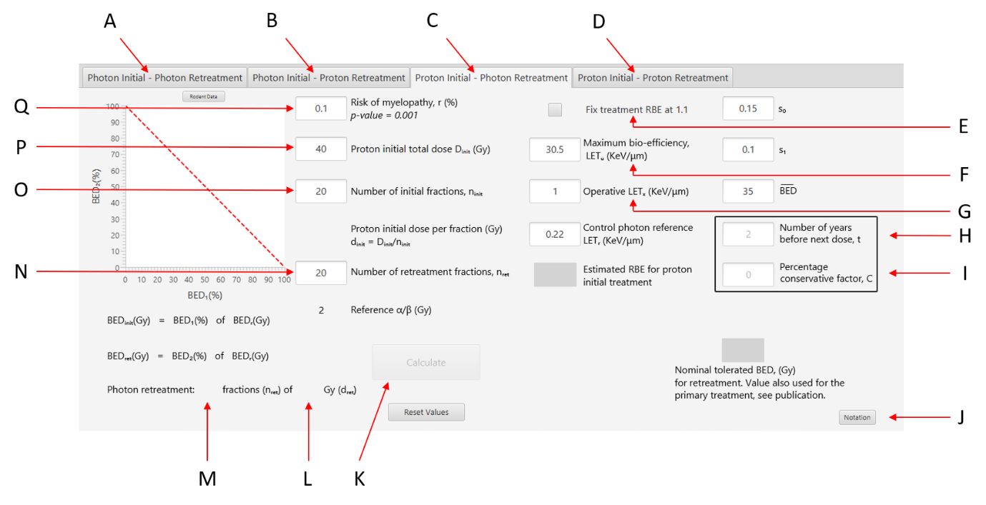

**Figure 2. Annotated screenshot of the GUI with initial proton treatment and photon retreatment window selected and default values. A-D are the tab buttons to select the corresponding combination of proton-photon treatments. E is the checkbox that fix the RBE at 1.1 for the initial proton. F refers to the ${LET}_{u}$ input boxes for initial treatment. G refers to the ${LET}_{x}$ input boxes for initial treatment. H is the input box time-elapsed between initial treatment and retreatment. I is input box for the conservative factor. J corresponds to the notation button that opens the window of definitions. K is the calculate button. L refers to where the retreatment doses are displayed. M refers to where the number of retreatment fractions are displayed. N is the input box for number of retreatment fractions. P-O refer to the initial dose and Q is the input box for the acceptable risk of myelopathy.**